Modifications of CIM rating rules 2022-2025

Here is a description of the main changes, with the corresponding explanations and justifications:
- Sail area Spv and sail aspect ratio Sf
- Bottom profile parameter Pp
- Authenticity and conformity coefficient Co
- Rigging coefficient Ca and original class coefficient Cb
- Formula of TCF for Time on Time classification

1 - Sail area Spv and sail configuration ratio Sf

Since the beginning of the CIM rating rule in 1999, the sail area has been estimated from the measurement of the useful lengths on the rig, to avoid having a systematic measurement and control of the sails which can be quite complex to implement.
HLU
I
This leads to a bias in relation to the actual surfaces used, in particular for the overlaps of the headsails, the roach of the mainsails, and the configurations of the downwind sails.
The CIM Rating Commission has decided on the following changes:
HLP
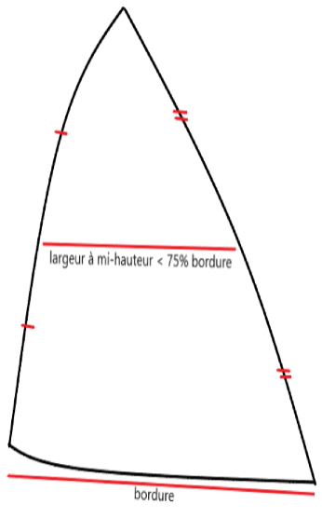
- Identification of headsails for upwind or reaching with overlap, to take into account the surface: 0,5·HLU·HLP
(when higher than 0,5·I·J)
Note: “Headsail for upwind or reaching” if its width at mid-height is less than 75% of its foot
J
- Weighting of 70% of the headsail surface for upwind or reaching (Spa), and 30% for downwind (Spo), with estimated downwind sail area of Spo = 0,8·I·(max between J and pool length)
- Consideration for ketches and yawls of a weighted surface for downwind staysails (on annual declaration): 0,15·mP·E
where mP is the maximum usable height for the mizzen sail, and E is the usable boom length of the foremast mainsail.

Note also a precision for the definition of the "balloon jib" configuration, of which it is specified that its tack point must be fixed on the deck at the front of the mast via a fixed strop of limited length (<0.2 J), whose clew is attached to a spinnaker pole, and whose width at mid-height is less than 75% of its foot.
The measurement regulations do not introduce any new penalties for mainsail roach, but the Rating Commission will remain very attentive to any deviation.
Regarding the sail aspect ratio Sf, deemed to be too significant in the past, a reduction of its influence was implemented via the square root of its formula.
Note also an adjustment in the R rating formula of the constant associated with the corrected sail area Spc, which goes from 0.36 to 0.34.

2 – Bottom profile parameter Pp
The objective of the Pp parameter is to characterize the hull performance from the longitudinal profile of the hull, with a separation into two types:
- Type 1 when the rudder is an extension of the lowest edge of the hull
- Type 2 when the rudder is separated from the centreboard
Concerning type 1 Pp, a modification has been made in the extremes of the variation range, which have been changed from [0.9 - 1] to [0.77 - 1.10] depending on the ratio between: the surface of the projection of the submerged part of the hull on the axial plane, and the surface of the rectangle: length at the waterline x draft.
This modification allows to better characterize:
- yachts with hulls with an inefficient anti-drift plan, allowing a significantly increased bonus – impact of up to 10% on the rating,
- and at the opposite yachts with very significant anti-drift planks, characteristic of more efficient hulls, with a maximum penalty of 10% on the rating.

Examples of type 1 extreme hull profiles:
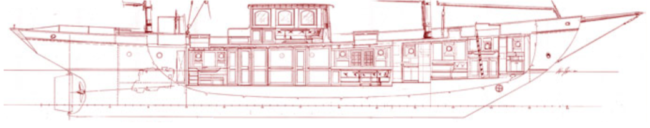
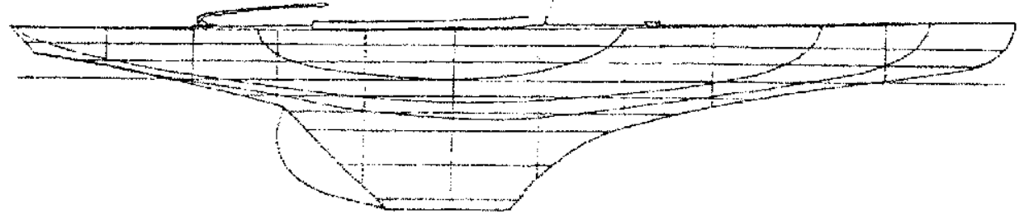

3 - Authenticity and conformity coefficient Co

Authenticity and conformity to origin has, since its origin, been a guideline of the CIM rating rule. The objective is double: first of all to preserve the historical and cultural heritage of classic yachting, and then to preserve yachts for which modernization would entail a risk of destruction and loss of meaning.
Nevertheless, the rating rule recognize the possibility of adaptation allowing regattas to be carried out in safety, or when materials or technologies are no longer available (cotton, hemp, etc.).
The changes to the CIM 2022 regulation target two factors:
- increase the weight of Co in the rating, thanks to an increase in the variation ranges
for example for vintage yachts, this range goes from [0.9 – 1.10] to [0.88 – 1.15]
- increase the relative weight of the rig in the calculation of the Co, by adding two explicit criteria: compliance with the original rigging configuration (number and respective size of the masts and spreaders) and compliance with the type of original mainsail (Gaff or Bermudian).
A better characterization of the standing rigging is also planned (and in particular the use of ROD or high modulus synthetic cables).
Note: this last point is reflected in the Pv - coefficient of equipment and fittings - by removing the penalty associated with the "mast with developed structure".

4 - Rigging coefficient Ca and original class coefficient Cb

Since the origin of CIM rating rule, the rig coefficient Ca allows to take into account the relative efficiency of the different types of rig (for example a Bermudan rig is deemed to be more efficient than a gaff rig, or a sloop more than a schooner…). Nevertheless, Ca was also associated with the penalization of certain original classes of yachts (for example metric IR, or California 32, etc.), because taking into account the technical characteristics of these yachts did not make it possible to obtain fair ratings.
These two characterizations not being of the same nature, the CIM Rating Commission decided to separate the variables and identify the original class with a new corrective coefficient Cb. This inclusion of original class coefficient is done with the aim of reducing its influence having implemented better consideration of the technical characteristics, and in particular the overlapping of the headsails. However, it was not possible to remove this factor, which is still necessary to obtain fair ratings according to our experience of regattas.
It should be noted that for the Ca, expurgated from the original classes, a new characterization is under analysis for Bermudian yachts for "Fractional rigging" (for example seven-eighth), whose highest point of the forestay (hound) is significantly lower than the top of the mast. Data is requested from ship-owners to analyse the situation.

5 - Formula of TCF for Time on Time classification

The usual system for calculating corrected times Tc for the CIM rating rule is Time on Distance:
Tc = C · Tr - APM · D
with Tr: real time, C: penalty or bonus (from article 15), D: the geographical length of the course, and APM: the allowance per mile, coming from the rating.
It is also possible to exceptionally use Time on Time: Tc = C · TCF · Tr
with the TCF calculated from the rating.
An experiment was carried out in France during the 2021 season with an adjusted TCF formula to improve performance (reduction of corrected time ranges). The results were positive from this point of view, however a side effect was observed with discrepancies in ranking compared to the results simulated with Time on Distance.
The CIM Rating Committee has therefore modified the constants of the TCF formula in order to limit the differences in classification compared to time on distance while maintaining an improvement in performance of corrected time:
New formula: TCF = 0,212 · (√R + 1,55)

CONCLUSION:
The modifications decided remain constrained by the means and the amateur state of mind that the CIM wants to keep for its measurement system (for example, the orientation of not weighing the boats has been confirmed). Nevertheless, it is necessary to make the data taken into account more reliable, and in particular the new data, such as those concerning the overlap of the headsails.
In order to allow the volunteer CIM measurers of the National Associations to collect reliable information, a form has been prepared to simplify the production of measurement certificates.
Thank you to the ship-owners for completing the rating questionnaires as quickly and accurately as possible!

